Topic 8:

Lesson 1: Arrays in Java

So far in previous lessons, we used the variables that hold only one value. An integer variable is capable of storing only one number etc.

**Array :**

An **array** is a type of variable that can store multiple values. It is like a list of items but it always contains similar data type values.

How to declare an array ?

* A Java array variable can be declared like other variables with [] after the data type.

Example 1

String []arr

(**arr** is a reference variable / array name ).

Example 2: if we want to store the names of 50 people then we can create an array of the string type that can store 50 names.

String []arr = *new* String[100];

new String [100] : 100 is the size of array . To declare the size of an array we use [@] . eg. int [] arrayName = new int [10] ,this is an array of integer type with size 10.

*double* [] arrayName = *new double*[20];

above array is a array of double datatype of size 20.

the above array cannot store more than 20 double values . ***The size of an array in a Java is always fixed(once initialized).***

**How to initialize an Array :**

* We can initialize arrays during declaration.
* *int* [] arrayName = {1,2,3,4,5};

We have created an array and initialized it with the values inside the curly brackets.

Note :

that we have not provided the size of the array. In this case, the Java compiler automatically specifies the size by counting the number of elements in the array

In the Java array, each memory location is associated with a number. The number is known as an array index. We can also initialize arrays in Java, using the index number.

Example 3:

*int* [] arrayName = *new int*[5];  
arrayName[0]=1;  
arrayName[1]=2;  
arrayName[2]=3;  
arrayName[3]=4;  
arrayName[4]=5;

**Note :**

* Array indices always start from 0. That is, the first element of an array is at index 0.
* If the size of an array is n, then the last element of the array will be at index (n-1).

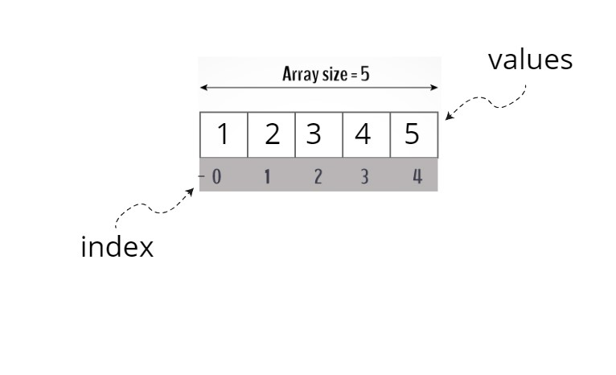

**How to Access Elements of an Array in Java ?**

Each variable in an Java array is also called an "element". Each element in the array has an index (a number). You can access each element in the array via its index.

From above Example 3 :

System.out.println(arrayName[0]);

System.out.println(arrayName[3]);

System.out.println(arrayName[2]);

Output-: 1

4

3

Challenge Yourself : create an array of String and store your teachers name.